WEEK 2 - OUTPUTS

**ADVANCED SQL-**

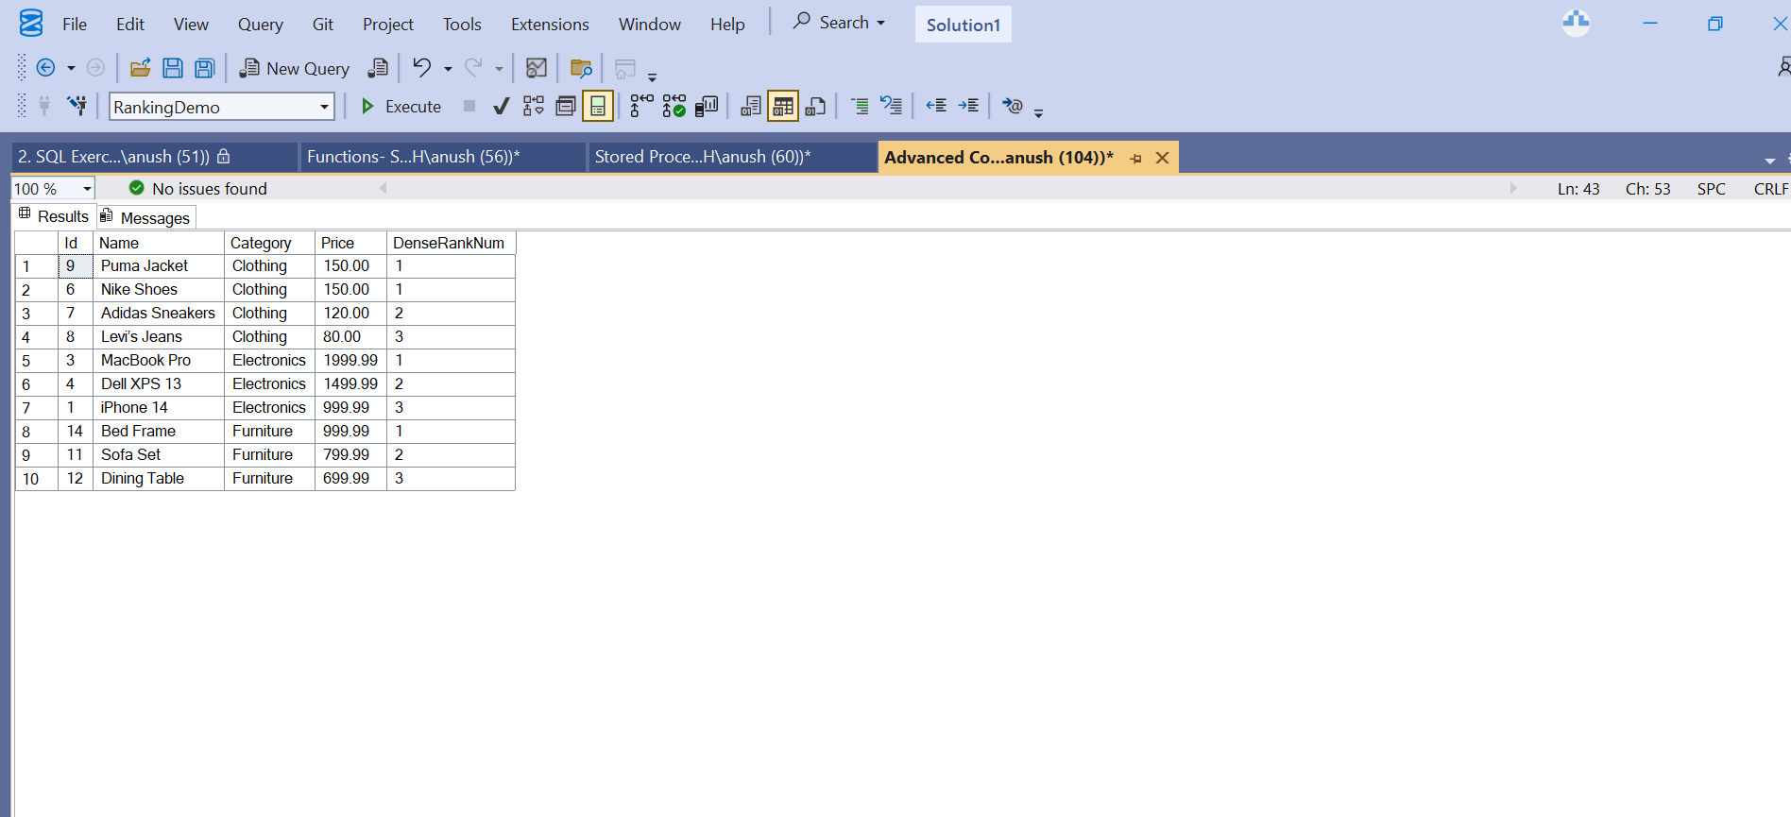

**STORED PROCEDURES -**

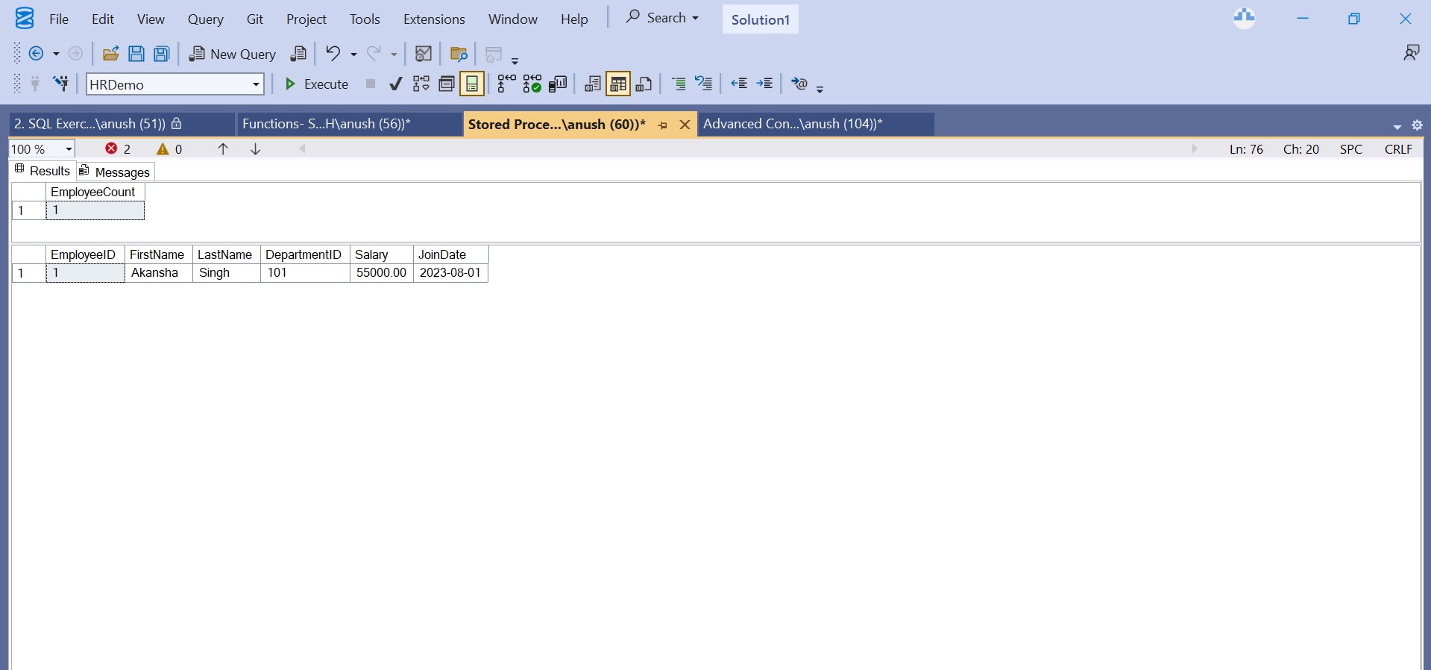

**FUNCTIONS -**

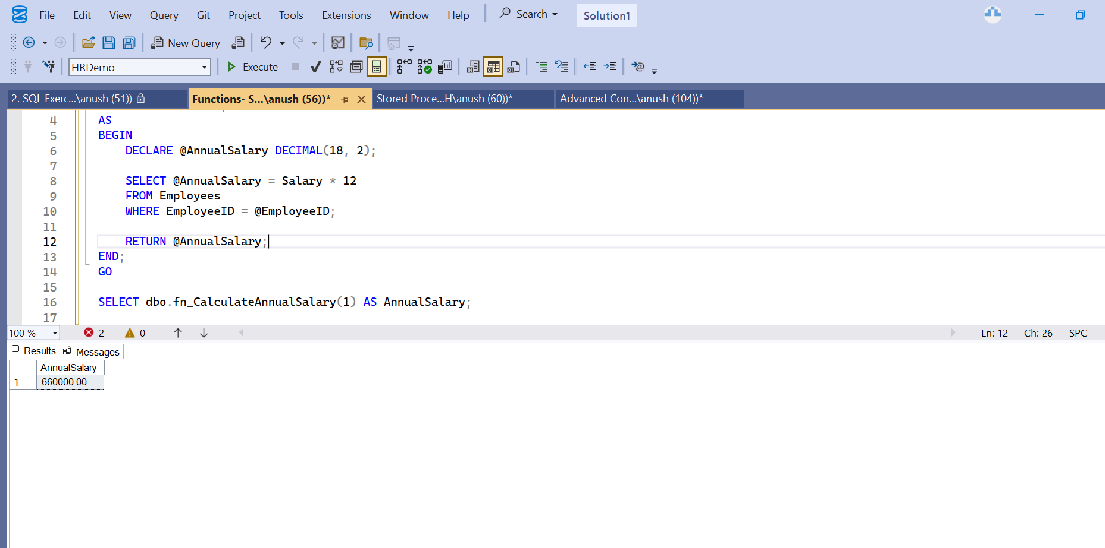

**INDEXES -**

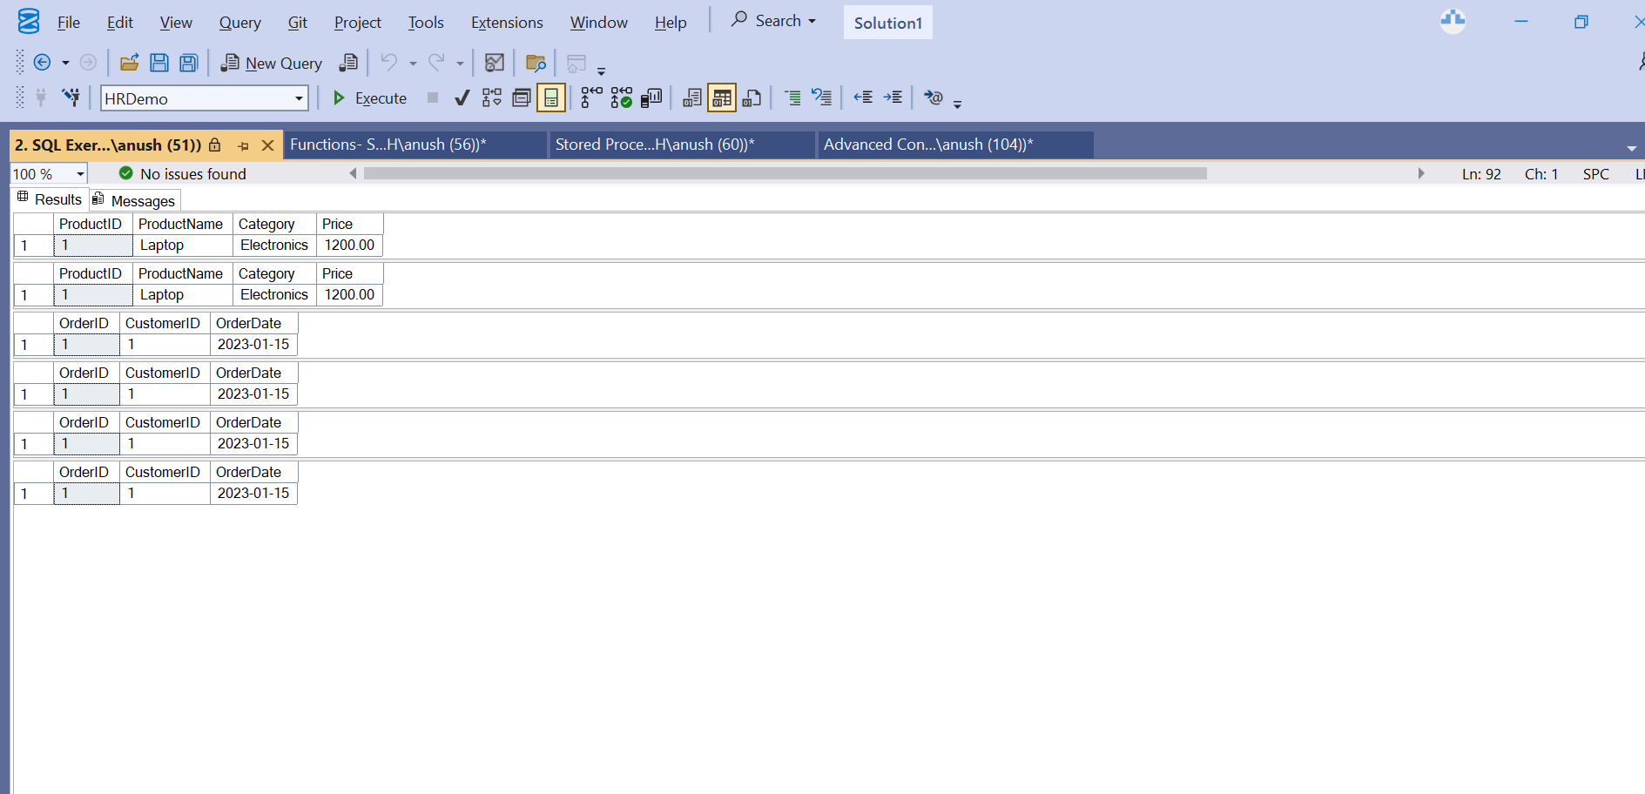

**MOQ TESTING -**

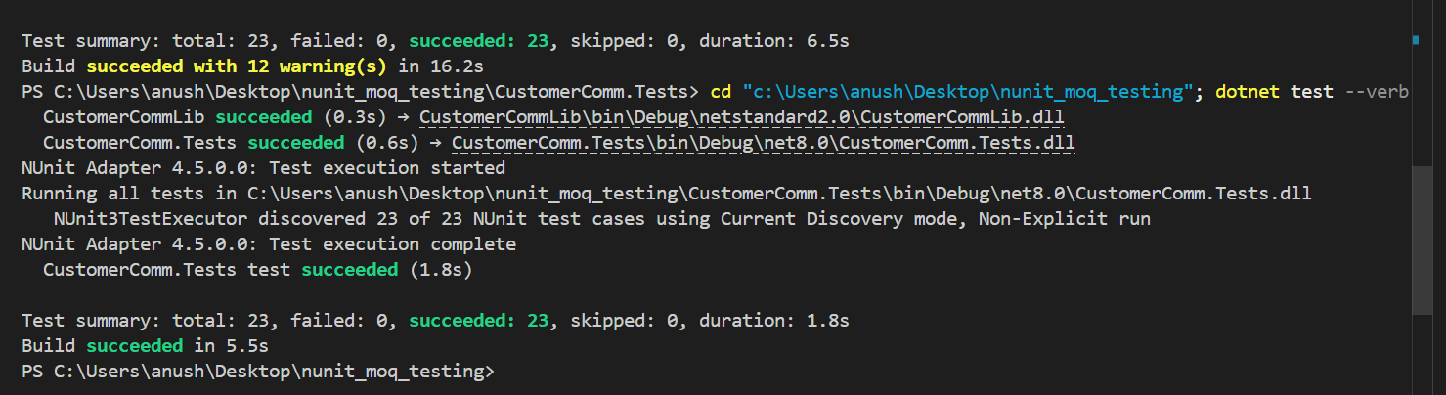

**NUNIT TESTING-**

